Insurance and IPA’s

Functionality: These are a series of screens grouped together that offer information about and related to a given organization. Within these screens, the user can edit, add or remove related information. The information is divided into several Tabs, Summary, and Insurance. There is also a Profile line, which gives basic information about the org. This line appears on each screen but is only editable from the Summary Page.

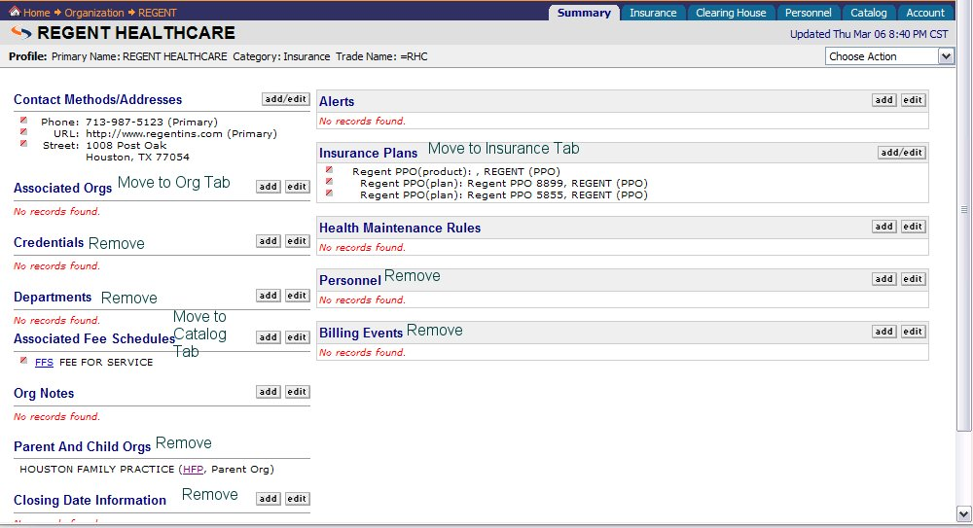

Profile Line:
The profile line allows the user to view basic information about the Org at all times when they are in the org. However, it is only editable from the Summary Page. Originally, the information obtained for the profile line comes from information added at Add-an- Insurance or Add-an-IPA. ****Please note, the only difference in the two orgs will be the category in the Profile line. One is Insurance and one is IPA. If the user needs to edit information on this line, they should be able to do so from the Summary Page. Currently, on Physia, there is a Choose action box drop. The only item needed in that box is Edit Profile. Once the user chooses to edit profile→application takes user to Edit Profile dialogue.
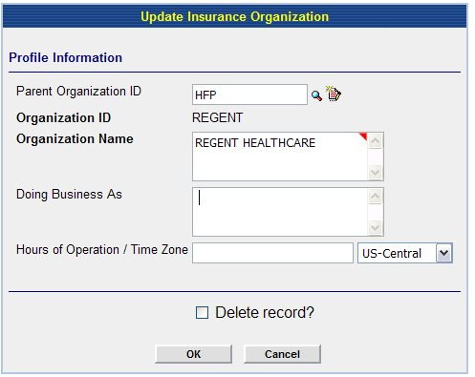
User makes changes→User clicks [OK] to save changes→application acknowledges update→application takes user back to Summary Page for Org.
***Note: Delete button should not delete record but put item in an archived file. There should be a user interface so that the user has access to this information at any given time.

Summary Page:

This tab consists of basic information that is directly related to the Org. On this page the user should be able to view/add/edit the following Categories: Contact Methods/addresses, Credentials, Org Notes, Health Maintenance Rules and Alerts. The users can add/edit information on this screen. The screen in Physia handles the majority of this but the following Categories should be removed:

Parent And Child Orgs: Removed
Associated Orgs: Removed
Departments: Removed
Personnel: Removed
Billing Events: Removed

Insurance Plans: Move to Insurance Tab

Category: Contact Methods/Addresses Priority 5
This category includes all contact information for Org.

Add/Edit Function

Functionality: The user has the ability to add or edit any entry from the summary page and other tabs within the Org. The add/edit function should function the same for each category on the summary page.

Add:
The user is able to add new information to a sub category by clicking the ADD/Edit button near the category. In Physia, it is a Hyperlink on the word Add/Edit. If the user does not see the information in the sub category and wishes to add it, then they click the hyperlink→application takes user to add/edit dialogue→
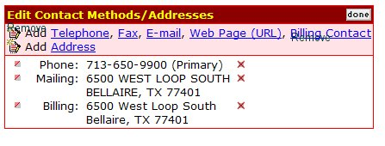**Note: Remove the Add icons , because it is redundant. Change billing Contact to Provider Representative.

The user clicks the item to add. (In this example it is Telephone) →Application takes user to dialogue for add telephone→
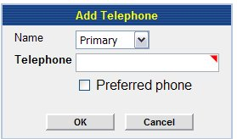
The user has the ability to choose which type of phone number they want to enter. This is in the form of a drop down box. 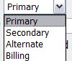. User enters required information
(Again marked with a required field indicator) →User clicks [OK]→application shows new information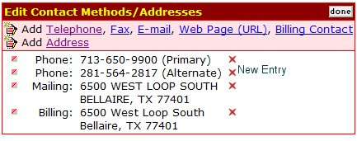

The user clicks [done]→ application takes user back to summary page.

If the user chooses to edit an existing item, at this point, they may choose the to the left of the item and the following dialogue on using the will begin.

Edit: The user can edit from a couple of ways. They can do the short cut and use the edit button in front of the existing item they wish to edit. (In Physia this is the .) Or the user can click the add/edit button on the category box. .

Takes the user directly to the edit dialogue for the item chosen. For example if the user chooses to edit the mailing address the following screen is displayed.

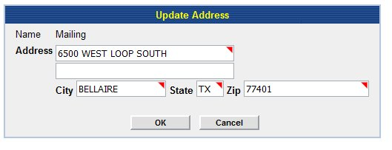
All the information is auto filled. The user simply uses the mouse to move the cursor to the correct box and enters the new information.→User clicks [OK]→application takes user to a screen that displays the edited information and a notification that update is complete: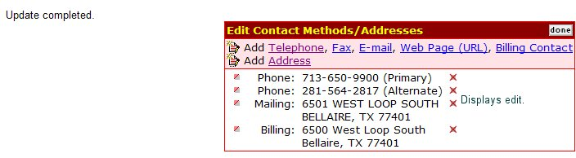

User clicks [done] →Application takes user back to Summary Page.
If user clicks in front of another entry→application takes user to edit dialogue for the chosen item→application continues loop until user clicks [done].

The application should follow the same line of actions for each item in a category. Any differences will be noted within the category below.

This is generally used for adding new items but the user is taken to the add/edit dialogue and has to click the icon in order to edit a field. Once they click the , the user is taken through the actions described above for the . This is a longer process but since the Add dialogue takes you to the same screen and a user can edit an existing item when there, it makes since to keep it. However, the user will be trained in the most efficient way to edit an item.

Org Notes: Not a Priority 5
These are notes pertaining specifically to the Org. In this case, users would use it for notes that pertain to the whole IPA or Insurance Org. Individual notes for plans and products will be done on their level.

Alerts: Not a Priority 5
These are alerts concerning the Org and display in order of Priority from High to Low.

Health Maintenance Rules: Not a Priority 5
Theses are rules concerning the Org.

Insurance Tab:
The insurance tab will contain the information currently listed on the Summary page of the Insurance and IPA orgs.
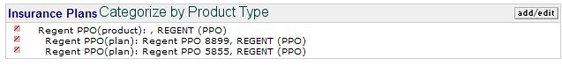
There should be a category for each Product Type in application. For example, the above tab would be labeled “PPO” and all products with their attached plans would be listed in this category. It will function like this category in Physia. The user should be able to add/edit within each Category. There are 14 different categories: Insurance, HMO Capped, HMO Non-capped, PPO, Medicare, Medicaid, Workers Compensation, Champus, Champva, FECA Black Lung, BCBS, Managed Choice, POS, Railroad Medicare.

ADD
The user can add an insurance product or plan from this tab. If the user clicks the Add button within a category→application takes user to a choice to add an insurance product or plan. →User chooses one→
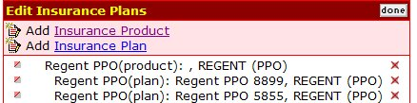

If the user chooses Insurance Product→ Application takes user to Add-Insurance Product Dialogue. The following fields should be auto filled Product type (with the product type where the add button is clicked) and Insurance Org (with the Org the user is viewing). (See Add-Insurance Dialogue for details of rest of screen). →Application should auto fill Insurance Org and Product type-based on the Insurance Org that the user is viewing at the time of choosing add and the category where the add is chosen. Application ignores next action and brings user back to Insurance Tab for Insurance/IPA Org.

If the user chooses insurance plan→application takes user to add-insurance plan dialogue. (See Add insurance plan document for details). →Insurance org should auto fill.→Application ignores next action and takes user back to Insurance Tab for Insurance or IPA Org.

Catalog:

Associated Fee Schedules
Associated Fee Schedules are fee schedules that are assigned to an Org. The user should be able to view, add or edit a fee schedule from this screen.

Add
The user can add a fee schedule by clicking the add button. When the user clicks the add button→application takes user add a fee schedule dialogue→
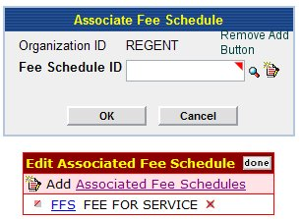→User can enter Id or utilize search engine→
If user chooses to use search engine→Application takes user to search engine for fee schedules→ this look up takes user to a search engine for an existing Fee schedule. The user should be able to pull up using the following criteria:
Fee Schedule Name, Fee Schedule ID, Description, Physicians linked to Fee Schedule, Locations linked to Fee schedule

Fee Schedule Name
Fee Schedule ID | **User enters ID
Description
Associated Physicians | **User enters ID(s)
Associated Site Organizations | **User enters ID(s)
Once user clicks [OK]→application pulls up results:
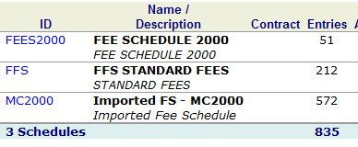
- User clicks look up→application takes user to search engine→user clicks Name/Description (Fee Schedule 2000)→application takes user to details of fee schedule
This is a view only screen. User closes screen→application takes user back to results→ if user sees the fee schedule for Copy, user clicks Fee Schedule ID→ Application pulls Fee Schedule ID into field for Fee Schedule ID.

Or
User clicks look up→application takes user to search engine→user does not see desired results and closes results window→application takes user back to look up for Fee schedule.

If Fee Schedule is found and user picks it→Application goes back to Add Fee Schedule dialogue and auto fills user’s choice→User clicks [OK]→application acknowledges add and takes user back to Catalog Tab for Insurance or IPA Org ***Is it possible to put the date this change was made-next to the Fee Schedule ID on the Catalog Tab? ***The Application should place the Insurance or IPA Org ID into correct field in the Fee Schedule’s dialogue.
A user should only be able to add existing Fee Schedules to the Associated Org.

Edit
Any changes to the Fee schedule in itself, should be done from the Catalog area in the Main Org.

Remove
A user can remove a fee schedule from an Associated Org by clicking the in front of the Fee Schedule Id→The application takes user to Remove Fee Schedule Dialogue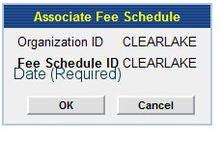the user must add a End date for Fee Schedule→user clicks [OK]→application acknowledges deletion→Application takes user to Insurance or IPA Org Summary Page→Fee schedule should show with the word “inactive” next to the name and the date.

